Literature Review on Sentiment Analysis of Cryptocurrency

In this project,we are trying to analyze sentiment over the cryptocurrencies in the social media like Reddit and Tweeter. We will be using supervised machine learning principles to Submissions of subreddits related to cryptocurrencies extracted from Reddit and analyze the correlation between cryptocurrency market movements with sentiments in social media. In an elaborate way, positive news and tweets in social media about a cryptocurrency would definitely encourage people to invest in the that particular currency and as a result the price of that currency would increase.

1. Past Works:

A popular publication in this field can be regarded as the J. Bean [1] work which uses keyword tagging on Twitter feeds about airlines satisfaction to score them for polarity and sentiment. This would provide a quick idea of the sentiment prevailing about airlines and their customer satisfaction ratings.

Nagar and Hahsler in their research [2] presented an automated text mining based approach to
aggregate news stories from various sources and create a News Corpus. A sentiment metric, called NewsSentiment, utilizing the count of positive and negative polarity words is proposed as a measure of the sentiment of the overall news corpus. Their paper shows that the time variation of
NewsSentiment shows a very strong correlation with the actual stock price movement.

Goonatilake et al [3] presented a study which indicates that news items have a strong association with economic indices and oil prices. They evaluate the impact of news items on majorindices such as Dow Jones Industrial Index (DJIA), S&P 500, and NASDAQ. They classify news items in four categories and try to measure their impact on the daily movement of stock prices by developing a regression model.

An approach by Stuart Colianni[8], Stephanie Rosales, and Michael Signorotti (Stanford University) was carried for determining the optimal time to trade involves correlating prices with one of today’s most popular social media sources, Twitter. When words in a tweet are treated as elements of the feature vector for each classifier, Bernoulli Naive Bayes performed the best out of all text classification algorithms by achieving an hour to hour accuracy of 76.23%.

Pagolu [4] work on predicting stock through tweeter sentiment presents a strong correlation between the Tweeter sentiment and stock price of Microsoft company. We are trying to develop a sentiment analysis algorithm based on this research.

2. Proposed Method:

2.1 Data Collection:
We are collecting data intially from Reddit using Reddit API. These data includes the Subreddit instance and their submission and all the comments to those submission. First we will work on submissions of subreddit to prepare a tranning and testing data set.

2.2 Pre-processing:
We have used python nltk module for the preprocessing of the collected data. We have applied different filtration techniques such as:
Tokenization:Submissions are split into individual words based on the space and irrelevant symbols like emoticons are removed. We form a list of individual words for each submission.

Stop Words Filtering: Words that do not express any emotion are called Stopwords. After splitting a submission, words like a,is, the, with etc. are removed from the list of words.
Regex Matching for special character Removal: Regex matching in Python is performed to match URLs and remove them from the submission.
Stemming : The words like developing, developed, development are from the root word develop so the process of stemming is used to create the root words which makes easier in feature extraction.

2.3 Preparing the Datasets:
The sentiment analysis is largely dependent on the context so the sentiment analysis for the products of online stores largely varies with sentiment analysis of the stock prediction. Since the cryptocurrentcies and their market are very new topic in todays wold. We are unable to find any proper dataset for training a classifier so we have to manually create some dataset.

Pagolu [4] and group have also created 3,216 manual annotated Tweets giving them 1 for positive 0 for neutral and 2 for negative tweets. So we will also create similar kind of data sets for the Reddit submission in required amount to meet the required accuracy of the algorithm.
2.4 Feature Extraction:

Word2vec representation is one of the advanced and a recent technique which functions by mapping words to a 300 dimensional vector representations. Once every word of the language has been mapped to a unique vector, vectors of words can be summed up yielding a resultant vector for any given collection of words as done in Tomas, M. [5] work. Relationship between the words is exactly retained in this form of representation. Word vectors difference between Rome and Italy is very close to the difference between vectors of France and Paris This sustained relationship between word concepts makes word2vec model very attractive for textual analysis. In this representation, resultant vector which is sum of 300 dimensional vectors of all words in a tweet acts as features to the model.

2.5 Model Training
The features extracted using the above methods for the manually annotated submissions will fed to the supervised machine learning classifier. In Pagolu [4] and various other realted work we have seen maximum use of Random Forest, SVM and Naive Bayes Classifier for sentiment analysis. And in most of the scenario Random Forest and SVM have performed well. So we have decided to use Random Forest Classifier as our machine learning tool for the sentiment analysis.

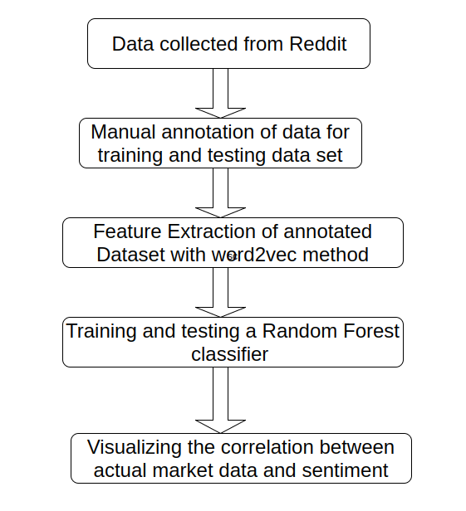

CONCLUSION:
From all above mentioned papers and text book we have decided to use word2vec for feature extraction from the submission of Reddit and we will be using Random Forest Classifier for the classification of submission based on sentiment into three categories positive, negative and neutral sentiment. In th work of Pagolu [4] they have achieved 71.6 percentage of accuracy so we will be aiming for the similar kind of accuracy and even more.

REFRENCES:

[1] J. Bean, R by example: Mining Twitter for consumer attitudes towards airlines.In Boston
Predictive Analytics Meetup Presentation, 2011

[2] Anurag Nagar, Michael Hahsler, Using Text and Data Mining Techniques to extract Stock
Market Sentiment from Live News Streams, IPCSIT vol. XX (2012) IACSIT Press, Singapore

[3] R. Goonatilake and S.Herath. The volatility of the stock markets and news. International Research Journal of Finance and Economics, 2007, 11:53-65

[4] V. Pagolu et. Al Sentiment Analysis of Tweeter Data for Predicting Stock Market Movements. International conference on Signal Processing, Communication, Power and Embedded System (SCOPES)-2016

[5] Tomas, M., Sutskever, I., Chen, K., Corrado, G. and Dean, J. (2013) Distributed Representations of Words and Phrases and Their Compositionality. Proceedings of Neural Information Processing Systems, Lake Tahoe, December 2013, 3111-3119

[6] R. Chen and M. Lazer, Sentiment Analysis of Twitter Feeds for the Prediction of Stock Market Movement, Cs 229, pp. 15, 2011.

[7] Evita and Jacob, Predicting Bitcoin price fluctuation with Twitter sentiment analysis

[8] Colianni, S.,Rosales and Signorotti M.(2015) Algorithmic Trading of Cryptocurrency Based on Twitter Sentimet Analysis

[9] Scikit-learn.:Machine Learning in Python 0.17 Documentation.
Web. 2 Feb. 2018.

